Sample Voucher
 |  |  | 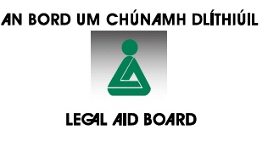
Scheme of Independent Advice
on Home Mortgage Arrears
Legal Advice Voucher

Name of Borrower(s):
Address of Principal Private Residence:
(PPR)
Voucher ID: |  |  |  | Scheme Reference No
Referring MABS office:
Nominated Panel Solicitor:
Date of Issue:
Dear Legal Aid Board,

I certify that the person meets the eligibility criteria for the Scheme I have explained the Scheme to the person and have provided the person with a list of solicitors on the Legal Aid Home Mortgage Arrears Panel. I attach the File Sharing Consent Form, duly signed by the borrower which has been explained to him/her prior to his/her signature, and undertake upon the borrower’s request to forward to the person’s solicitortheir Standard/Prescribed Financial Statement and standard file documents.

Name and position of authorised signatory on behalf of MABS (print in capitals)
on behalf of __________________________________ Limited (MABS Company)

I accept legal advice on the terms offered and consent to the transmission of my personal details to the Legal Aid Board and the Nominated Solicitor.

Signed _____________________________(Borrower) Date _______________

TO THE NOMINATED SOLICITOR:
Check the date of issue of this voucher. If more than three months have elapsed since issue, advise the person to return to MABS. Please retain a copy of this voucher and return a copy to the Legal Aid Board when claiming payment

