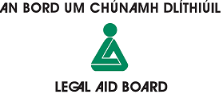 | Claim for Fees  Abhaile Duty Solicitor Service

Solicitor
Circuit Court Venue
Date |  | Time list commenced

Fee claimed: Half Day |  | Full Day

Details of persons to whom services were provided:

Name | Voucher ID & Scheme numbers | Address PPR | Plaintiff (lender) | Record No

I certify that I have provided the legal services as set out and I accordingly seek payment of the appropriate fee in accordance with the terms and conditions for the provision of legal services under the Terms and Conditions of the Abhaile Solicitors Panel.
Liable for VAT : YES/NO |  | VAT No. if applicable
Signature: | Solicitor |  | Date

Office use | Name | Date
Received by
Checked by
Authorised by

