Application Form for the Position Of
Solicitor Grade III Galway
  - October 2026

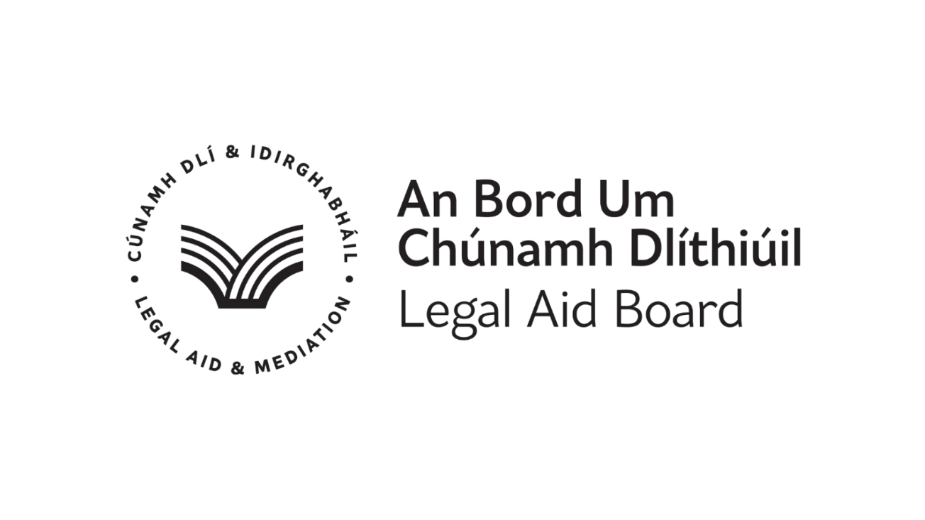
The Legal Aid Board Privacy Statement Regarding Job Applications

In order for the Legal Aid Board to accept your application form, you must provide consent for the Legal Aid Board to process your job application in line with the Legal Aid Board Privacy Statement regarding Job Applications and GDPR Requirements.
This statement (the “Privacy Statement”) aims at informing you of how the Legal Aid Board will use the personal date you submit when applying for a job at the Legal Aid Board ("Job Application Data"). All Job Application Data you submit to the Legal Aid Board is retained in the Legal Aid Board.
This Privacy Statement covers any Job Application Data you submit, such as:
- Name, Home address, email address, telephone number, or other contact information;
- Information contained in your CV or cover letter, such as previous work experience, education, or other information you provide for our consideration; however, we are requesting a completed application and a CV is not required;
- Type of employment sought, and
- Names and contact information for referrals.
It is your responsibility to obtain consent from references before providing their personal information to us. For the avoidance of doubt, the Legal Aid Board does not wish to receive any confidential or proprietary (or patented) information which you have received from your previous employers.
Only select employees of the Legal Aid Board - such as your potential future manager(s), employees of the Human Resources Department, and IT (for maintenance purposes only) - and select employees of our external service providers, who support the Legal Aid Board with the administration of recruitment applications, have access to your Job Application Data.
The Legal Aid Board will not supply any of your submitted data to any third party other than those identified above without your express authorisation.
The Job Application Data you provide will be used to assess your application for employment at the Legal Aid Board, to verify your information and conduct reference checks, and to communicate with you.
If you accept employment with the Legal Aid Board the information collected will become part of your employment record and will be used for employment purposes only.
Your Job Application Data is stored in our data base for the lifetime of the competition panel plus 1 year for employment law purposes. A record of the competition and related data may be retained for 7 years as per our Records and Destruction Policy, e.g. advertisement, information booklet, applications received, a list of successful candidates.

I understand that all data submitted as part of an application for job will be treated as confidential by the Legal Aid Board, that it will process and retain such data only in line with GDPR requirements. I also understand that the Board will process my personal data in line with Freedom of Information Requirements. I acknowledge that further information about the Board’s Data Protection and Freedom of Information policies is available on www.legalaidboard.ie.The Board’s Data Protection Section can be contacted at dataprotection@legalaidboard.ie. The Board’s Freedom of Information Section can be contacted at foi@legalaidboard.ie .
Please tick the box to confirm consent to the Legal Aid Board processing your application in accordance with the above Privacy Notice.

Application Form for Recruitment Competition for Solicitor Grade III Galway
Candidates must read the accompanying information booklet before completing the Application Form. This Application Form should be competed and returned to: recruitment@legalaidboard.ie not later than: 4.00pm on Monday 2nd November 2026
Section A
1. | Surname
2. | First Name(s)
3. | Address to which correspondence should be sent
4. | Contact details
 | Mobile/ phone
 | Email
5. | Are you under the age of 70 years (which is the compulsory retirement age) and at least 17 years of age? |  | Yes No
6. | Are you an Irish citizen, a citizen of the European Economic Area (EEA), or eligible to work in Ireland |  | Yes No
7. | Have you previously applied for a position with the Legal Aid Board? If yes, what year? |  | Yes No  Year _________
8. | Do you hold a current practising certificate
9. | Date on which you first obtained a practising certificate
10. | Number of years practising experience since admitted
11. | Are you currently employed as a solicitor
12. | The Legal Aid Board is an Equal Opportunities Employer. We promote inclusivity and diversity in the workplace and actively welcome applicants from all backgrounds. Interviews will be held remotely. Do you require accommodations to be made during the recruitment process. |  | Yes No
13. | Where did you find this role advertised? (Legal Aid Board website, Facebook, LinkedIn, Newspaper etc.)

I hereby declare the particulars entered above and in Sections B, C, D of the application form to be correct.

Signature |  |  | Date

Section B
Part 1 – Education Details
Examination(s) passed | Year | Overall Result (Pass, Hons, Grade)

Part 2 – Academic and/or Professional Qualification
Degree or Qualification held | Year |  | College Attended | Result in final Exam (1,2.1,Pass etc)

Part 3 – Name two responsible persons, to whom you are well known but not related, as referees:
Name | Occupation | Email Address
Name | Occupation | Email Address

Part 4 – What qualities do you consider you possess which would make you particularly suitable for employment with the Board?
please limit your response to 500 words

Section C
Previous Experience

For your most recent employments within the last 10 years please complete Section C (I) below.
NOTE: Your career history is best presented in reverse chronological order so that the most recent roles appear first.
Supplementary pages may be added for this purpose if required.
Section C (I)
Title of post held:
Dates to and from (DD/MM/YYYY) | From: | DD/MM/YYYY | To: | DD/MM/YYYY
Name and address of employer
Reason for leaving
Brief description of responsibilities and achievements
please limit your response to 200 words

Title of post held:
Dates to and from (DD/MM/YYYY) | From: | DD/MM/YYYY | To: | DD/MM/YYYY
Name and address of employer
Reason for leaving
Brief description of responsibilities and achievements
please limit your response to 200 words

Title of post held:
Dates to and from (DD/MM/YYYY) | From: | DD/MM/YYYY | To: | DD/MM/YYYY
Name and address of employer
Reason for leaving
Brief description of responsibilities and achievements
please limit your response to 200 words

Section C (II)
For all previous employments held more than 10 years ago, please complete below.
Positions held more than 10 years ago require only a summary description.

Particulars in date order of all other previous employments / unemployment or experience to date. Supplementary rows may be added for this purpose, if required.

From (date) | To (date) | Title of post held | Name and address of employer

Section D
Key Achievements
For each of the areas below, please briefly highlight and illustrate specific key achievements, you have developed from your career to date which clearly demonstrates your suitability to meet the challenges of the role of a Solicitor Grade III in the Legal Aid Board.
Please restrict your answers to a maximum of 500 words.

Professional expertise/knowledge and ability to provide excellent legal services
Analysis & Decision Making
Management and Delivery of Results
Interpersonal & communication skills
Personal Drive and Commitment to Public Service Values

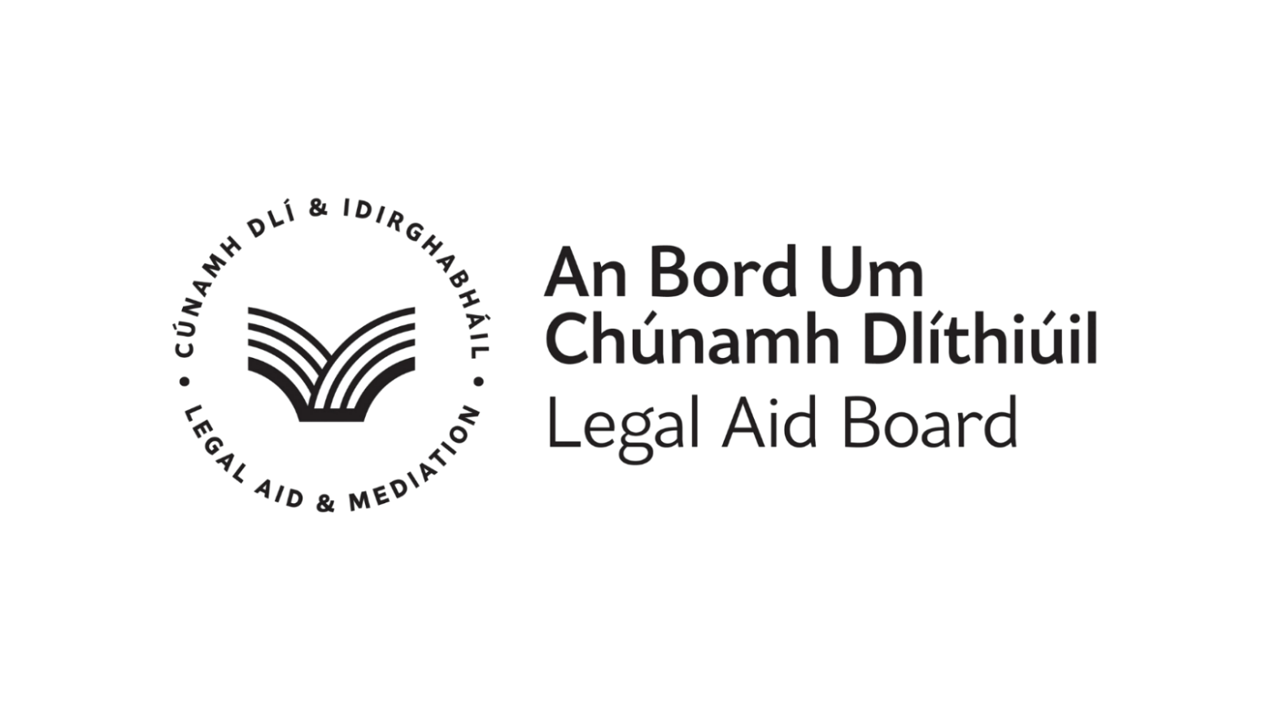

Contact Us
Human Resources
Legal Aid Board
Quay Street, Cahirciveen,
Co Kerry V23 RD36
Phone 066 947 1021
Email recruitment@legalaidboard.ie

